It has been observed that some auction cases are either missing addresses, zip codes or counties.

Find screenshots below

1. Cases with missing addresses only

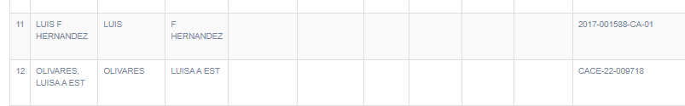

Find cases list [here](https://docs.google.com/spreadsheets/d/1a0zhiLa_szisqO96y9LvA8IT1rek6QzMoTddKqPsSp0/edit?usp=sharing)

1. Cases with missing counties

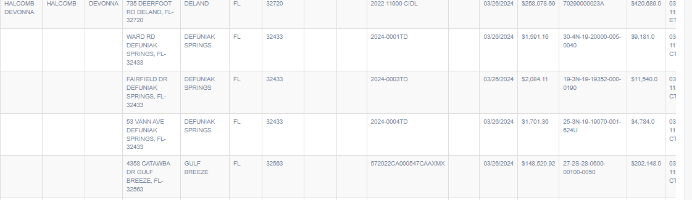

Find cases list [here](https://docs.google.com/spreadsheets/d/1EQFTfxlPrPqXTs8coiE55KgLuA94LbY9gfHHnfo_ysI/edit?usp=sharing)

1. Cases with wrong state and zip codes are found mostly with Broward county

